
ERASMUS+ Programme –Key Action 2: Strategic partnership
IENE 10- “PREPARING HEALTH AND SOCIAL CARE WORKERS TO WORK WITH SOCIALLY ASSISTIVE ARTIFICIALLY INTELLIGENT ROBOTS IN HEALTH AND SOCIAL CARE ENVIRONMENTS”
Agreement number: 2020-1-UK01-KA202-078802
Newsletter
No. 1
June 2021

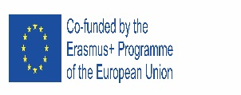






Aim  and  Objectives |  | The use of technology has been shown to improve patient safety, as well as the quality, accessibility and efficiency of care. Technology has been used to help older people to cope at home and in an effort of trying to solve the challenges faced by the ageing population.  Socially assistive robots may act as enabler in health and social care.  Social assistive robot: Its target is to create close and effective interaction with a human user, to provide assistance and achieve measurable progress in rehabilitation learning, etc  alongside or instead of physical aid.  The IENE 10 project aims to produce a Transcultural Robotic Nursing (TRN) curriculum model and learning materials which will be suitable for health and social care workers and educators, not only within the partnership of this project but also internationally.  Objectives  a) Raise awareness about the potential advantages of AI and Socially Assistive Robots in health and social care;  b) Gain knowledge and understanding about both negative and positive implications of AI and Socially Assistive Robots on health and social care;  c) Gain knowledge and understanding of the relevance of ethics related to the development and deployment of AI and Transcultural Robotics Nursing (TRN); | THE PARTNERS
The project  Outputs |  | d) Gain skills and knowledge of the practical aspects of deploying AI & TRN in health and social care;  e) Achieve a satisfactory level of knowledge and understanding, in their self and formal assessment to be administered during the TRN-MOOC.  The main expected tangible products of the project are:  - Development of the Transcultural Robotics Nursing (TRN) Curriculum Model  - Development of the Transcultural Robotics Nursing (TRN) Modules  - Developing Learning Tools  - Setting up and Delivering the Transcultural Robotics Nursing (TRN) MOOC  - Piloting the Content, Recruiting Strategy and Organising the MOOC Groups  - Development of the MOOC Facilitators' Training Manual and Development of the MOOC Assessment Strategy
Kick of Meeting (online), January 22, 2021  Second (online) Meeting, May 12, 2021 |  | The partners familiarized themselves with all aspects of the project, adopted the work plan, evaluation strategy and dissemination plan.  They established the communication, monitoring and reporting procedures and discussed about the financial and contractual rules.  The Consortium discussed the O1 in detail and agreed that it will be very important to search recent International, European and national publications and reports on TRN related issues particularly those related to training of the workforce.  They discussed the website plan and agreed on the social media use for the project.  Overall monitoring guidelines were highlighted by the Coordinator. The partners made comments, suggestions and discussed Intellectual outputs IO 1.1 and IO 1.2.  Partners also discussed IENE 10 website and possible improvements. An introduction was done to IO 2. | 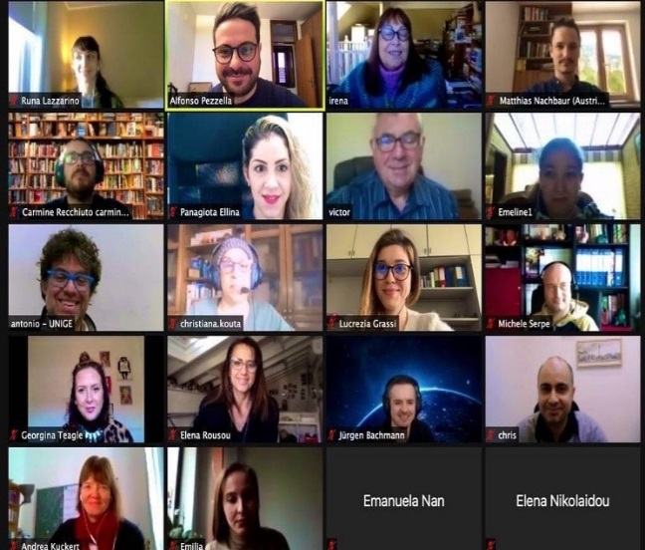
Output no. 1.1  Review of the Literature  Output no. 1.2  Transcultural Robotics Nursing (TRN) Curriculum Model |  | The first output is the Development of the TRN (Transcultural Robotics Nursing) Curriculum Model, regarding:  - The review of the PTT/IENE model  - The development of the Transcultural Robotics Nursing (TRN) curriculum model  - The translation of the TRN curriculum model in all the languages of the partner countries.  The aim is to identify the needs, challenges and advantages of Transcultural Robotics Nursing (TRN).  The project aims to produce a European Transcultural Robotic Nursing (TRN) curriculum model and learning materials which will be suitable for training health and social care workers and educators, not only within the partnership of this project but also internationally. The TRN curriculum model will be used as a guide for the development of the training modules, materials, learning tools and finally the creation and implementation of the online training course.  This will be based on mapping of the literature (O1) as well as evidence from the previous IENE projects and will include a training guide and good practices.  The curriculum will be translated into all partners languages: EL, DE, IT, RO. Reports of the TRN literature review and the Curriculum are available at http://ieneproject.eu/IENE10/about-results.php
Next meeting |  | Next meeting will be in Cyprus on July 2021
This project has been funded with support from the European Commission. This publication reflects the views only of the author, and the Commission cannot be held responsible for any use which may be made of the information contained therein. |  |         

